

Academic Year: 2025-2026

WEB - APPLICATION TRAINING REPORT ON

“Java Development”

Course: DIPLOMA
Branch: COMPUTER ENGINEERING

SUBMITTED TO THE JSPM BHIVRABAI SAWANT POLYTECHNIC
WAGHOLI

BY

Name: Savni Sainath Tudme Enrollment number: 23211820451

UNDER THE GUIDANCE OF
Ms. Sayali Ambekar



Vision and Mission of the Institute

Vision:

To develop globally competent technocrats by imparting quality technical education for social economic enhancement of the nation.

Mission:
M1: To nurture and maintain an environment of high academic standard for diploma students, encouraging higher education and entrepreneurial abilities.

M2: To deliver quality education by imparting basic engineering knowledge, inter personal skills, critical thinking and creativity.

M3: To equip students with technical skills, ethical and moral values to meet aspirations of the society and industry to contribute sustainable development of the nation



Computer Engineering Department

Academic Year: 2025-2026

Vision:

To develop technical manpower in the field of computer engineering to contribute the Socio-industrial requirement.

Mission:
M1: To develop techno-savvy engineers by imparting comprehensive computer engineering knowledge by innovative teaching and learning process.
M2: To develop professional skills committed for lifelong learning through co- curricular and extracurricular activities.
M3: To impart Computer Engineering education in order to meet societal and industry needs.

Course Coordinator Module Coordinator HOD

Index

Sr. No. | Content
1 | Index / Content Page
2 | Certificate by Institute
3 | Acknowledgement
4 | Abstract
5 | Introduction
6 | Objective
7 | Vision Mission of the project
8 | Theory
9 | Workflow
10 | Algorithm
11 | Flowchart
12 | Program
13 | Output
14 | Applications
15 | Advantages
16 | Conclusion
17 | Reference

I feel immense pleasure in thanking my mentor Ms. Sayali Ambekar for her support, constant encouragement, consistent guidance and inspiration throughout this web application training. Her willingness to motivate me contributed tremendously to my web application training project and its report. Her guidance and discussions with him/her are invaluable in realization of this web application training report.
I express my sincere thanks to our H.O.D, Prof. Sonali Patil, for providing all the facilities towards completion of this In-plant Training.
I thank Prof. Ragvendra Kadakol Training & Placement Officer, JSPM Bhivrabai Sawant Polytechnic, Wagholi for his valuable suggestion regarding this In-plant training.
I would like to acknowledge Principal, Prof. Kale Sir for providing with a good environment and facilities to complete this web application Training. I am also thankful to the staff of Computer Engineering Department.
Finally, an honorable mention goes to my family and friends for their understanding and support shown towards me in completing this web application Training project.

Abstract
This internship at Dezykode IT Solutions Pvt. Ltd., Kharadi (Pune) provided the opportunity to work on the project Eco Tracker – Carbon Footprint Calculator. Dezykode is a technology-driven company specializing in software development, web solutions, and digital services, with a focus on innovation and client-centric applications.

The project aims to create a web-based platform that calculates and monitors an individual’s carbon footprint based on lifestyle inputs such as transportation, energy usage, food habits, and waste generation. Built using HTML, CSS, JavaScript, Angular, and MySQL, the system allows registered users to view personalized dashboards, detailed reports, and eco-friendly recommendations, while guest users can access general awareness content.

Unlike traditional systems, the Eco Tracker automates emission calculations, categorizes data, and presents insights through interactive charts. It not only raises awareness but also motivates users to adopt sustainable practices.

This project contributed to bridging academic knowledge with industrial application, enhancing technical skills, and demonstrating how IT solutions can promote sustainability. For Dezykode, the project enriches its portfolio with a socially impactful and innovative solution aligned with global sustainability goals.

INTRODUCTION :

Welcome to STYLESTITCH – Your Fashion Hub
At StyleStitch, we believe fashion is an art form that reflects individuality, creativity, and innovation. Our platform is designed to bring together fashion enthusiasts, designers, and trendsetters in one collaborative space where ideas can flourish and inspiration never ends.
Share Your Dress Concepts
Whether you have a unique outfit design in mind or a vision you wish to bring to life, StyleStitch provides you with the space to share your concepts with a like-minded community. From initial sketches to detailed descriptions, your ideas can inspire others and grow into something extraordinary.
Discover a World of Fashion
Explore a diverse collection of dresses and styles from around the globe. From modern, contemporary designs to timeless traditional wear, StyleStitch offers endless possibilities for those seeking fresh ideas or looking to showcase their personal sense of style.
Connect and Collaborate
Join a dynamic community of fashion lovers and professionals. Exchange ideas, seek feedback, and collaborate to transform creative concepts into real-world designs.
Why Choose StyleStitch?
- Access a growing collection of fashion inspirations
- Showcase your creativity on an interactive platform
- Connect with a global network of fashion enthusiasts and designers
- Stay informed about emerging trends and styles
At StyleStitch, we don’t just celebrate fashion — we empower individuals to create, share, and explore a world of endless style possibilities. Begin your journey with us today and be part of a community where fashion meets innovation.

Objectives of the Website
The primary objective of this website is to provide an intuitive, user-friendly, and fully functional online platform for custom-tailoring services. The website aims to bridge the gap between traditional tailoring and modern e-commerce solutions by enabling customers to design, order, and track personalized clothing from the comfort of their homes. The following points outline the objectives in detail:
- User-Centric Design and Accessibility
The website is designed to offer a seamless and visually appealing user experience. Customers of all age groups should be able to navigate the platform with ease, view products, customize their orders, and place them without any technical difficulty. Accessibility across devices, including desktop, tablet, and mobile, is a key objective, ensuring responsive design using frameworks like Bootstrap.
- Customization and Personalization
One of the core objectives is to allow customers to personalize their clothing according to their preferences. Users can select from various categories such as formal wear, traditional wear, party wear, jackets, and more. Options like choosing fabric, color, design patterns, measurements, and additional custom features empower users to create clothing that reflects their unique style.
- Integration of Measurement and Style Options
The website aims to simplify the measurement process by providing digital forms, guides, and tips for accurate input. Users can save their measurements for future orders, ensuring consistency and reducing the chances of errors. Advanced features may include visual previews of customized clothing to enhance the decision-making process.
- Secure and Efficient Ordering Process
Another objective is to establish a secure and efficient workflow for placing orders. The website facilitates user authentication, shopping cart management, order confirmation, and payment processing. Integration of trusted payment gateways and secure data handling is a priority to ensure customer confidence and trust.
- Real-Time Tracking and Order Management
The platform aims to provide real-time tracking of orders, enabling users to know the status of their custom-made clothing at each stage—from stitching to delivery. Admin functionalities allow staff to efficiently manage orders, monitor production progress, and ensure timely delivery.
- Educational and Informative Content
The website also seeks to educate users about fabric types, latest fashion trends, and tailoring techniques. By including tips, blogs, and tutorials, the platform enhances user engagement and positions itself as an authoritative source for fashion and tailoring knowledge.
- Customer Support and Feedback Integration
To enhance customer satisfaction, the website integrates robust support features such as live chat, contact forms, and FAQs. Feedback collection mechanisms help in continuously improving the services and user experience based on real-time customer input.
- Business Growth and Market Expansion
From a business perspective, the website aims to expand the reach of tailoring services beyond geographical boundaries. By leveraging e-commerce capabilities, it facilitates scalability, customer retention, and brand loyalty. It also allows for marketing campaigns, promotions, and personalized offers to engage both existing and potential customers.

Vision and mission
At StyleStitch, we believe fashion is more than just clothing; it is an art form, an expression of individuality, and a celebration of creativity. Our primary goal is to create a platform where every user feels valued, inspired, and empowered to share their unique ideas with the world.
Our vision is to prioritize our users’ ideas and bring their creativity to life by providing them with a seamless, interactive space to showcase their designs. We aim to appreciate and encourage every individual’s contribution, making StyleStitch a hub for innovation and collaboration in the fashion world.
We are committed to building a user-friendly platform that simplifies the process of customizing and ordering dresses. From intuitive navigation to step-by-step guidance in design uploading and fabric selection, every feature is designed to provide an effortless experience for our users.
At StyleStitch, we strive to:
- Encourage Creativity: By giving users a stage to showcase and share their unique dress ideas.
- Empower Individuals: Through a platform that celebrates originality and supports custom fashion.
- Ensure User Satisfaction: With a smooth interface, clear processes, and reliable delivery services.
- Connect Fashion Communities: By bringing together designers, stylists, and enthusiasts in one space.
Our ultimate mission is to bridge the gap between imagination and reality, turning user visions into beautifully crafted garments while creating a vibrant and supportive fashion community.

Theory

HTML
- Theory Learned: HTML defines the structure of web pages using elements and semantic tags. I learned about the importance of meaningful markup, accessibility attributes, and proper nesting of elements.
- Application in Project: Used semantic HTML (<header>, <main>, <footer>) for better structure, ensuring each page of the project is cleanly organized and accessible.

CSS
- Theory Learned: CSS styles elements through selectors, properties, and values. The box model (content, padding, border, margin) controls layout. Responsive design is achieved with media queries and flexible units.
- Application in Project: Customized theme colors and spacing to maintain a brown-and-white branding. Media queries ensure the UI adapts to mobile and desktop screens.

Bootstrap
- Theory Learned: Bootstrap’s grid system provides a responsive 12-column layout, and its components (cards, navbars, modals) offer ready-to-use designs with utility classes for spacing, color, and typography.
- Application in Project: Implemented flip-card product layouts and responsive banners for the Men’s and Women’s sections using Bootstrap’s grid and card components.

Java
- Theory Learned: Java is an object-oriented language emphasizing encapsulation, inheritance, polymorphism, and abstraction. Exception handling ensures robust execution.
- Application in Project: Backend services are written in Java, where I structured classes for entities (User, Order, Product) and used exception handling to manage errors like invalid user input or database failures.

JavaScript
- Theory Learned: JavaScript enables dynamic content through DOM manipulation, event handling, and asynchronous programming with promises and async/await.
- Application in Project: Added interactivity to forms (live validation, dynamic error messages) and product pages (filtering and sorting) within Angular components.

Angular
- Theory Learned: Angular organizes applications into reusable components, uses data binding for syncing UI with logic, and has routing for navigation without reloading. Services manage shared data.
- Application in Project: Built a multi-step order form using Angular Reactive Forms, routed between sections like Men, Women, Order Summary, and Order Tracking.

Spring Boot
- Theory Learned: Spring Boot simplifies backend development using auto-configuration, REST controllers, dependency injection, and Spring Data JPA for database operations.
- Application in Project: Created REST endpoints for orders, products, and user authentication. Used @RestController and @Autowired to handle client requests from Angular.

MySQL
- Theory Learned: MySQL stores data in relational tables with relationships defined via primary and foreign keys. SQL commands perform CRUD operations and joins.
- Application in Project: Designed tables for users, orders, and products. Implemented relationships between them to track orders per user.

Postman
- Theory Learned: Postman is used to test APIs by sending HTTP requests, setting headers, and verifying responses.
- Application in Project: Tested all Spring Boot endpoints for authentication, order creation, and product retrieval before integrating them into the Angular frontend

Workflow
The workflow of StyleStitch outlines how users navigate and interact with the website to explore fashion, upload their ideas, and customize their orders. The website is designed to be simple, interactive, and user-friendly, ensuring an effortless experience for every visitor.

1. Home Page
- Navigation Bar: Includes key sections:
  - Home
  - Women
  - Men
  - Kids
  - Fabric
  - Donate
  - Profile
- Carousel Section: Displays rotating posters about discounts, trending styles, and featured designs.
- Marquee: Shows scrolling text for announcements, offers, or quick updates.
- Cards Section:
  - Card 1: How to Choose Fabric
  - Card 2: Measurement Guide
  - Card 3: Meet Your Tailor
- Footer: Contains links to About Us, Contact, Terms & Conditions, Privacy Policy, and Social Media icons.

2. Category Pages (Women, Men, Kids, Fabric)
- Each category leads to its dedicated page showcasing collections and filters for easy browsing.
- Users can view products, read details, and add items to their custom design or cart.

3. Profile Section
- Users can register or log in.
- Manage their uploads, saved designs, and order history.

4. Upload & Customization
- Users can upload dress ideas (image or description).
- Choose fabric and provide measurements.

5. Donate Section
- Allows users to donate unused clothes to support a cause.

6. Order Tracking & Delivery
- Once an order is placed, users can track its progress until delivery
Algorithm :
• Start
- Open the StyleStitch website.
- Display the Home Page with featured designs, ongoing offers, and measurement guidelines.
• Navigation
- Show a Navigation Bar with categories:
  - Men
  - Women
  - Kids
  - Fabrics
  - User Profile
• Browse Sections
- Allow users to explore multiple sections within each category (e.g., casual wear, party wear, traditional).
• Upload Design
- Enable users to upload an image or provide a detailed description of their custom dress idea.
• Place Order
- Allow users to confirm and place an order for their customized dress.
• Track Order
- Provide an option to view order details and track the progress in real-time.
• Delivery
- Notify the user of the estimated delivery date and ensure timely delivery of the customized dress.
• End

Flowchart
Start

Navigation

Browse section

Upload Design

Place order

Track order

Delivery

End

Code : (home page)
<!-- Carousel -->
<div id="carouselExample" class="carousel slide mb-5" data-bs-ride="carousel" data-bs-interval="2000">

<!-- Indicators -->
<div class="carousel-indicators">
<button type="button" data-bs-target="#carouselExample" data-bs-slide-to="0" class="active dash-indicator" aria-current="true" aria-label="Slide 1"></button>
<button type="button" data-bs-target="#carouselExample" data-bs-slide-to="1" class="dash-indicator" aria-label="Slide 2"></button>
<button type="button" data-bs-target="#carouselExample" data-bs-slide-to="2" class="dash-indicator" aria-label="Slide 3"></button>
</div>

<!-- Carousel Inner -->
<div class="carousel-inner">
<div class="carousel-item active">
<img src="/fashion.png" class="d-block w-100 banner-img" alt="celebrity fashion">
</div>
<div class="carousel-item">
<img src="/sale.png" class="d-block w-100 banner-img" alt="discounts">
</div>
<div class="carousel-item">
<img src="https://www.childsafefoundation.org/img/newimages/donation%20clothes.jpg" class="d-block w-100 banner-img" alt="donation">
</div>
</div>

<!-- Controls -->
<button class="carousel-control-prev custom-arrow" type="button" data-bs-target="#carouselExample" data-bs-slide="prev">
<span class="carousel-control-prev-icon"></span>
</button>
<button class="carousel-control-next custom-arrow" type="button" data-bs-target="#carouselExample" data-bs-slide="next">
<span class="carousel-control-next-icon"></span>
</button>
</div>

<!-- Marquee -->
<div class="marquee-wrapper">
<div class="marquee-track">
<div class="marquee-content">
<i class="fa-solid fa-hand-holding-dollar"></i><b>Affordable</b>
<i class="fa-solid fa-certificate"></i><b>Quality-check</b>
<i class="fa-solid fa-scissors"></i><b>Custom Tailoring</b>
<i class="fa-solid fa-truck-fast"></i><b>Fast Delivery</b>
<i class="fa-solid fa-handshake-angle"></i><b>Trusted by 10,000+ Customers</b>
<i class="fa-solid fa-recycle"></i><b>Sustainable Fabrics</b>
</div>
<div class="marquee-content">
<i class="fa-solid fa-hand-holding-dollar"></i><b>Affordable</b>
<i class="fa-solid fa-certificate"></i><b>Quality-check</b>
<i class="fa-solid fa-scissors"></i><b>Custom Tailoring</b>
<i class="fa-solid fa-truck-fast"></i><b>Fast Delivery</b>
<i class="fa-solid fa-handshake-angle"></i><b>Trusted by 10,000+ Customers</b>
<i class="fa-solid fa-recycle"></i><b>Sustainable Fabrics</b>
</div>
</div>
</div>

<!-- Measurement Guide -->
<section class="measurement-guide container my-5 text-center">
<h2 class="section-title">Perfect Measurements, Perfect Fit</h2>
<div class="row align-items-center">
<div class="col-md-6">
<div class="video-container">
<iframe width="100%" height="315"
src="https://www.youtube.com/embed/jvGEVbgIXPU?autoplay=1&mute=1&loop=1&playlist=jvGEVbgIXPU"
title="Body Measurements Guide"
frameborder="0"
allow="autoplay; encrypted-media"
allowfullscreen>
</iframe>
</div>
</div>
<div class="col-md-6">
<p>Accurate body measurements are important to ensure a perfect fit, comfort, and a neat appearance in clothing. Watch our quick guide to take your measurements the right way.</p>
<button class="btn btn-brown px-4" routerLink="/measurement">
View Measurement Guide
</button>

</div>
</div>
</section>

<!-- Fabric Section -->
<section class="fabric-section container my-5 text-center">
<h2 class="section-title">Choose the Right Fabric</h2>
<div class="row align-items-center">
<div class="col-md-6">
<p>Choosing the right fabric is essential for making comfortable and durable clothes. Explore our curated fabric options to suit your style and comfort.</p>
<button class="btn " (click)="exploreFabrics()">
Explore Fabrics
</button> </div>
<div class="col-md-6">
<a href="https://cottonsandsatins.com/collections/all-fabrics" target="_blank" rel="noopener noreferrer">
<img
src="https://sourceitright.com/cdn/shop/articles/Blog_Banner_Images_2_600x.jpg?v=1654522819"
alt="Fabric Guide"
class="img-fluid rounded shadow"
/>
</a>
</div>
</div>
</section>

<!-- Know Your Tailor -->
<div class="container my-5">
<div class="row">
<div class="col-md-4" *ngFor="let tailor of tailors">
<div class="card tailor-card shadow-sm">
<div class="card-img-wrapper">
<img [src]="tailor.image" class="card-img-top" alt="{{tailor.name}}">

</div>
<div class="card-body text-center">
<h5 class="card-title">{{ tailor.name }}</h5>
<p class="card-text">{{ tailor.tagline }}</p>
</div>
</div>
</div>
</div>
</div>

<!-- How It Works Timeline -->
<section class="timeline-section container">
<h2 class="section-title">How It Works</h2>
<div class="timeline">
<div id="timelineLine" class="timeline-line"></div>

<div class="timeline-item left">
<h5>
1] Select Style & Fabric</h5>
<p>Browse our collections and choose the design and fabric that suits your taste and needs.</p>
</div>

<div class="timeline-item right">
<h5>2] Upload Measurements</h5>
<p>Use our measurement guide or video tutorial to submit your accurate body measurements.</p>
</div>

<div class="timeline-item left">
<h5>3] Tailoring in Progress</h5>
<p>Our expert tailors start crafting your outfit with precision and quality control.</p>
</div>

<div class="timeline-item right">
<h5>4] Delivery at Your Doorstep</h5>
<p>Once ready, your outfit is carefully packed and delivered straight to your home.</p>
</div>
</div>
</section>

(2.mens page)
<div class="banner" style="background-image:url('https://www.cbazaar.com/blog/wp-content/uploads/2023/11/Blog_Banner_Nov02_04.jpg')">

</div>

<div class="container mt-5">
<div class="row">
<div class="col-md-6 mb-4" *ngFor="let category of categories">
<div class="card h-100 shadow">
<img [src]="category.image" class="card-img-top" alt="{{ category.title }}" style="height:300px; object-fit:cover">
<div class="card-body">
<h5 class="card-title">{{ category.title }}</h5>
<p class="card-text">{{ category.description }}</p>
<a [routerLink]="['/mendetails']" [queryParams]="{ category: category.categoryKey }" class="btn btn-dark w-100">Explore More</a>
</div>
</div>
</div>
</div>
</div>
import { CommonModule } from '@angular/common';
import { Component } from '@angular/core';
import { RouterModule } from '@angular/router';

@Component({
selector: 'app-men',
standalone: true,
imports: [CommonModule, RouterModule],
templateUrl: './men.html',
styleUrl: './men.css'
})
export class Men {

categories = [
{ title: 'Formals', description: 'Elegant and sharp formals for every event.', image: 'https://redflame.in/cdn/shop/articles/formal_shirts_banner_hos_520x500_d46a0181-46de-4a37-9867-6f316cb7efd3.jpg?v=1739946465', categoryKey: 'formals' },
{ title: 'Jackets', description: 'Trendy jackets for bold and classy style.', image: 'https://iqaasports.com/pictures/4_banner.jpg', categoryKey: 'jackets' },
{ title: 'Traditional Wear', description: 'Celebrate culture in ethnic styles.', image: 'https://encrypted-tbn0.gstatic.com/images?q=tbn:ANd9GcRE3prNL7D1e_3vPrFdcc8ZIVaGqF2mNuSKTQ&s', categoryKey: 'traditional' },
{ title: 'Party Wear', description: 'Dress to impress at every celebration.', image: 'https://www.sloshout.com/blog/wp-content/uploads/3for2_banner_1024x1024.png', categoryKey: 'party' }
];
}

Output : (1.home page)
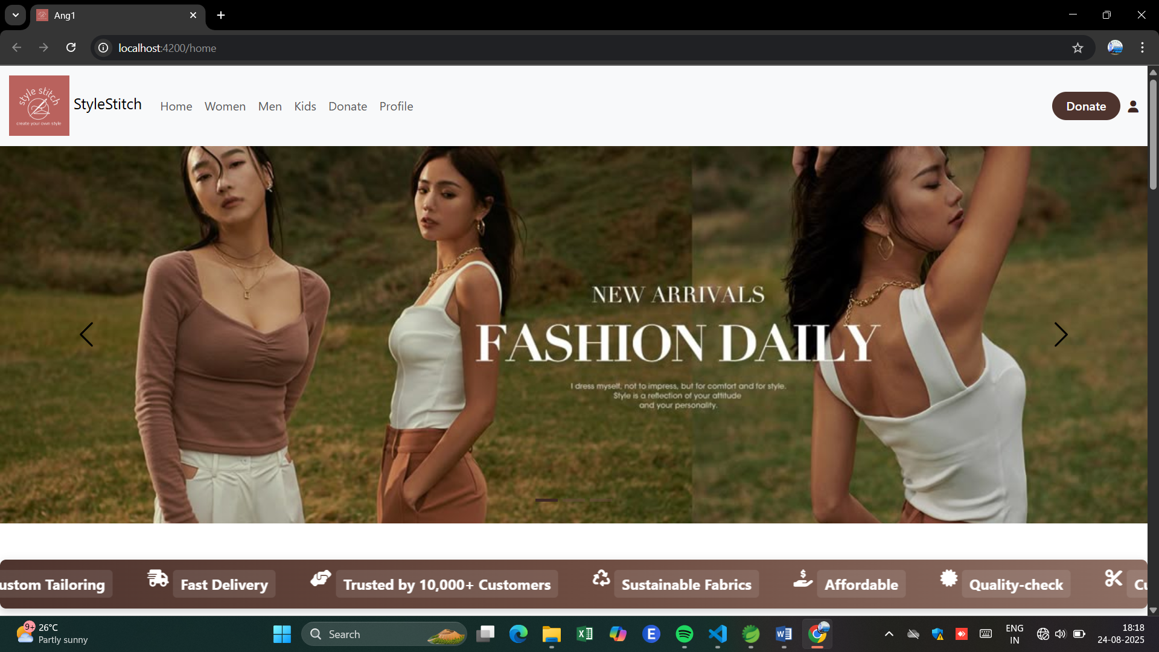
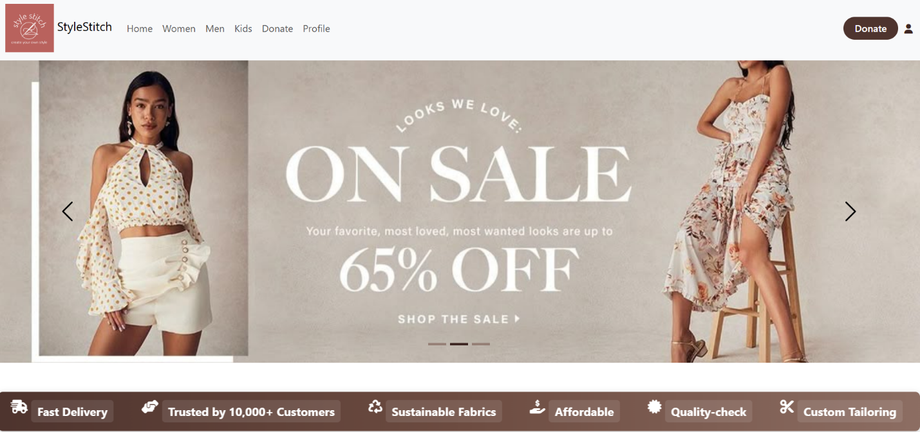
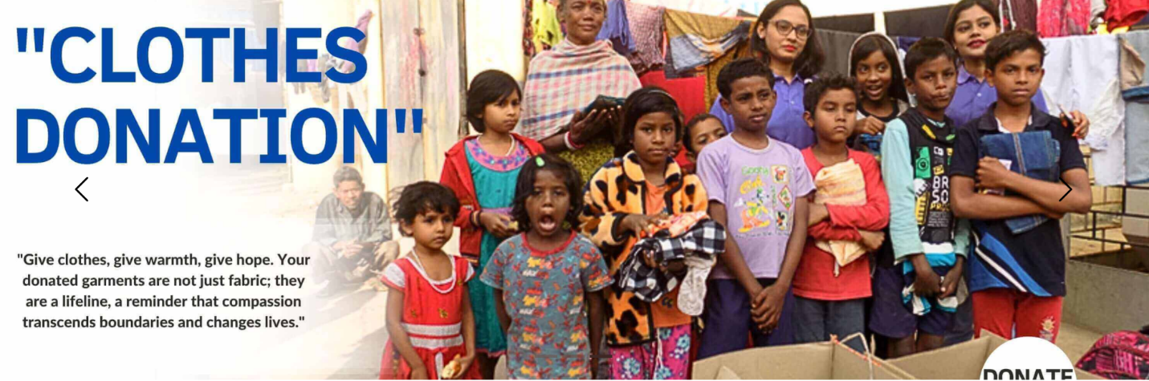

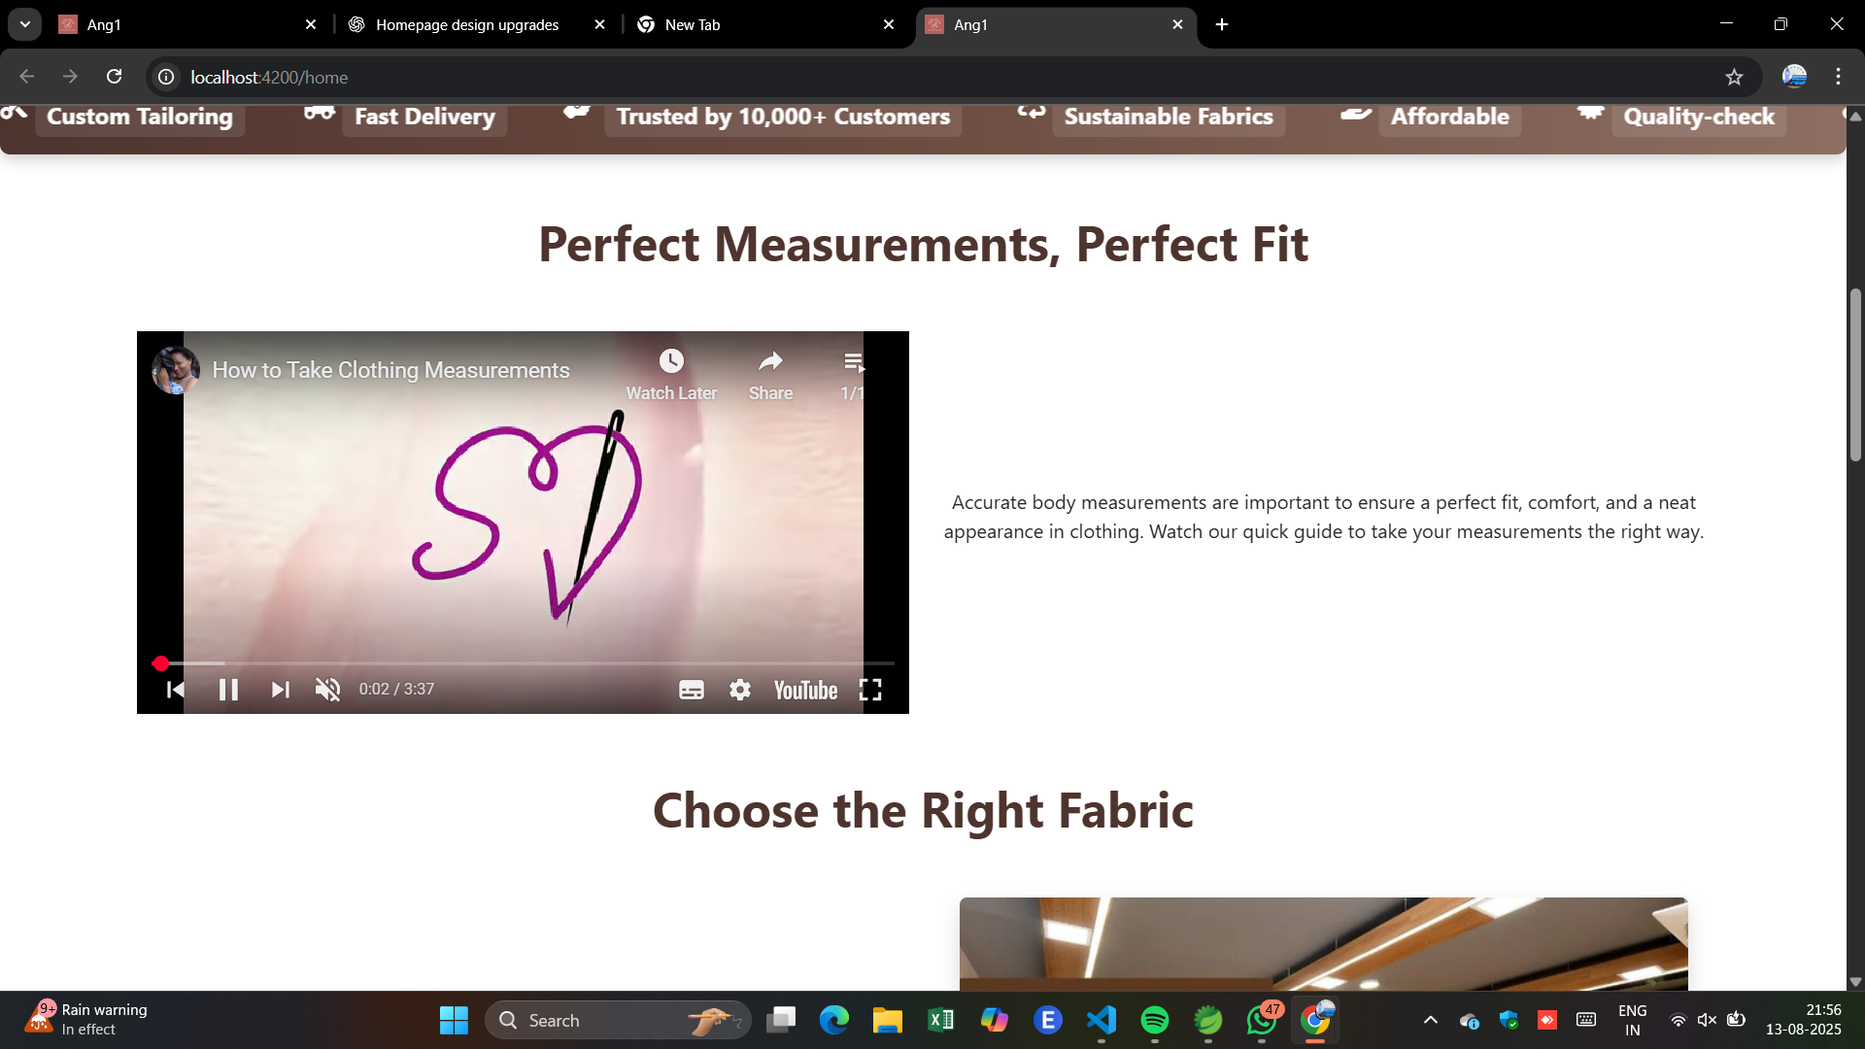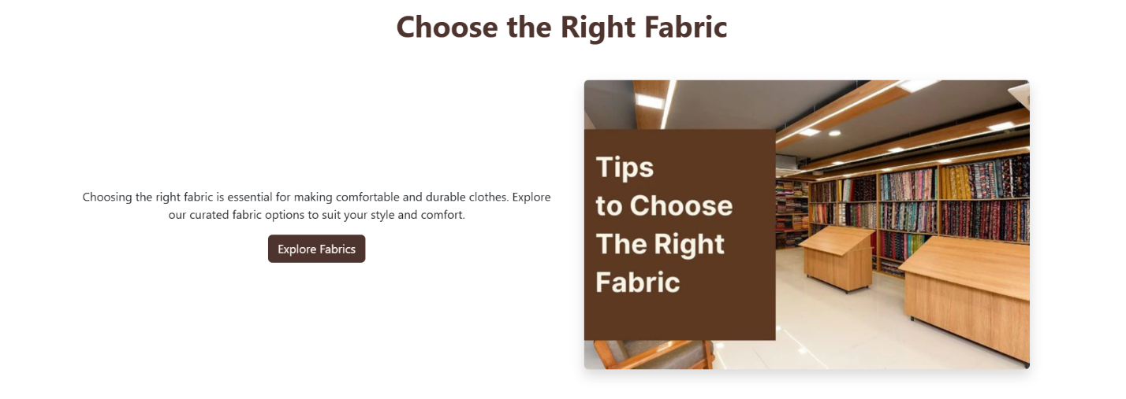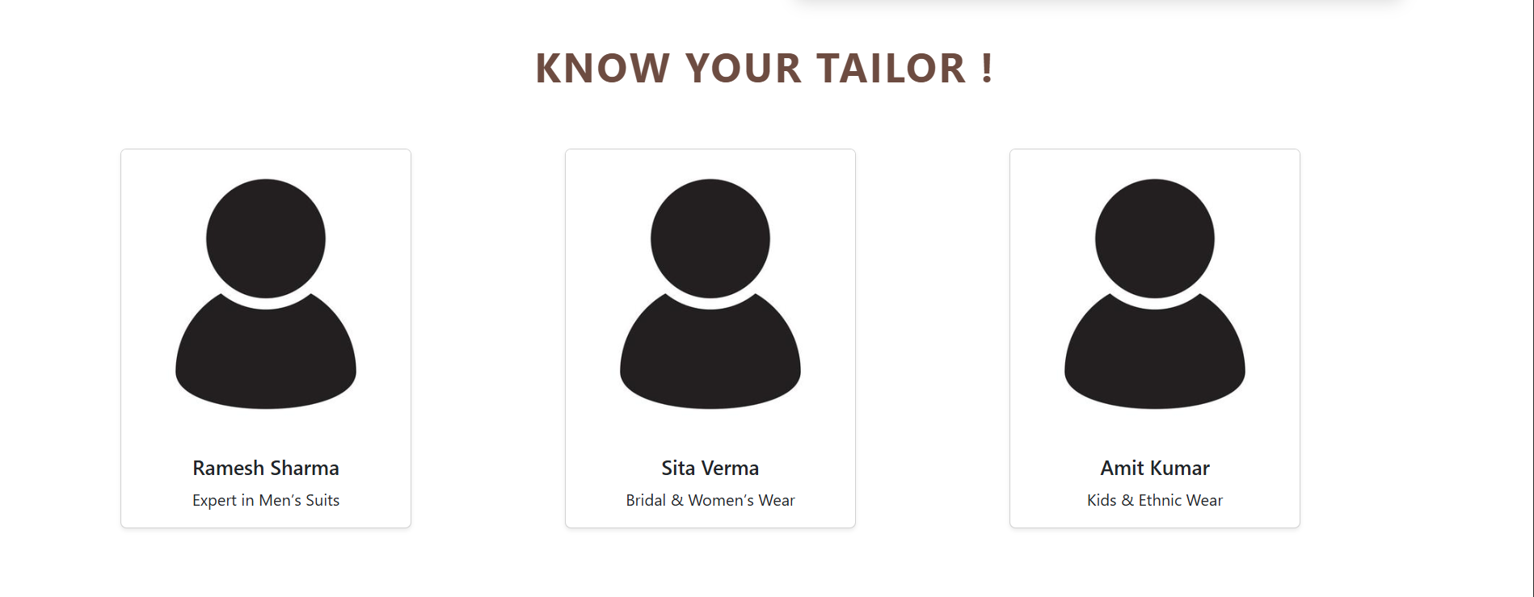

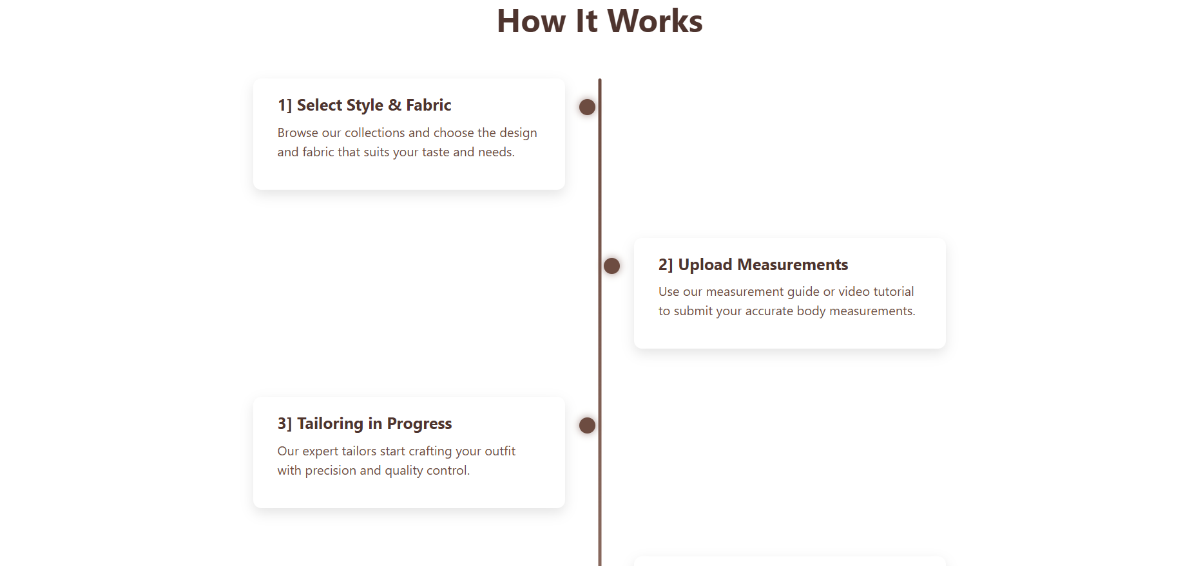
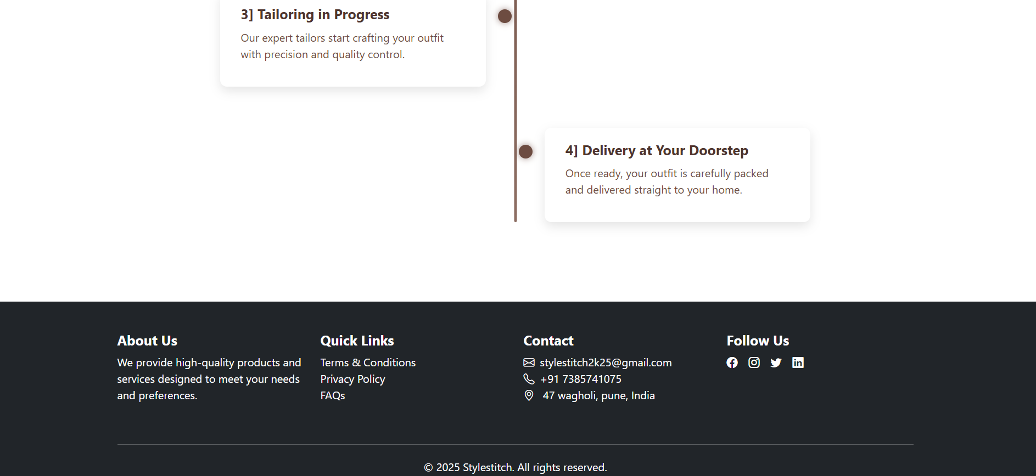

(2.mens page)

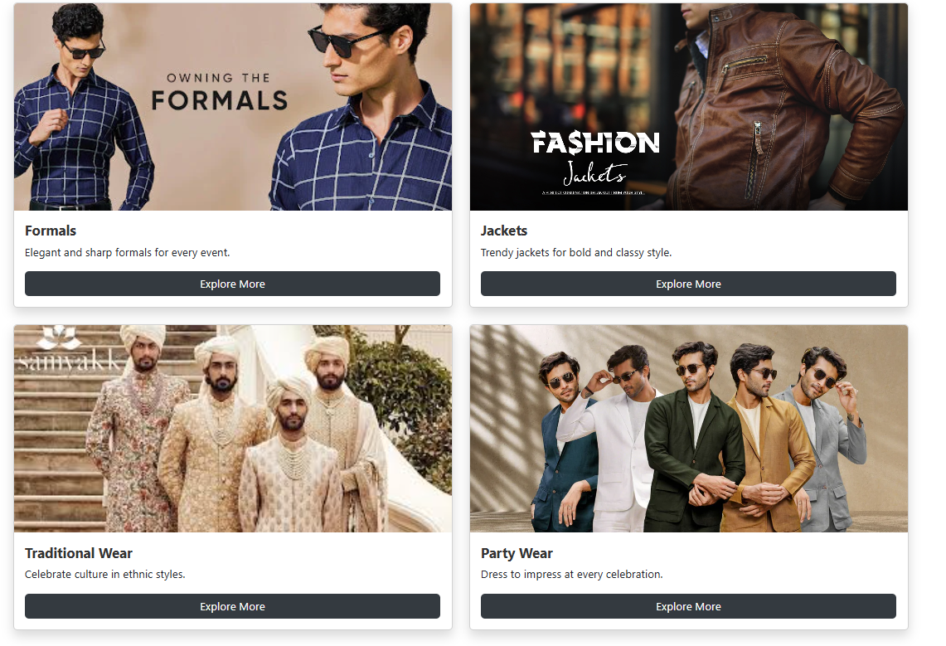
Application
- Custom Dress Designing
  - Users can upload their dress ideas, sketches, or descriptions to create unique customized outfits.
- Fashion Inspiration Hub
  - Browse a wide variety of dresses for men, women, and kids to get inspiration for new styles and trends.
- Personalized Shopping Experience
  - Offers tailored recommendations based on user preferences and previous activity.
- Online Dress Customization Orders
  - Customers can place orders for customized dresses and have them crafted as per their measurements and design preferences.
- Virtual Fashion Community
  - A space for designers, stylists, and fashion enthusiasts to share and exchange ideas.
- Order Tracking System
  - Users can track the progress of their customized dress from order confirmation to doorstep delivery.
- Fabric Selection Assistance
  - Helps users select fabrics for their custom designs by providing details and suggestions.
- Exclusive Offers & Discounts
  - Displays ongoing discounts, seasonal sales, and promotional offers to attract and retain users.

Advantages

- Customization Options
  - Allows users to upload their own dress ideas and get them tailor-made as per their preferences.
- Wide Variety of Designs
  - Offers an extensive collection of styles for men, women, and kids, catering to all fashion needs in one place.
- User-Friendly Interface
  - Simple navigation and intuitive layout make it easy for users to browse, upload designs, and place orders.
- Fabric and Measurement Guidance
  - Helps users select the right fabric and provides measurement tips for perfect fitting.
- Order Tracking Feature
  - Keeps users informed about the status of their order from placement to delivery.
- Time-Saving and Convenient
  - Eliminates the need for physical visits to tailors or boutiques by providing an online customization platform.
- Community Engagement
  - Connects fashion lovers, designers, and stylists in one interactive space to exchange ideas and feedback.
- Exclusive Offers and Discounts
  - Attracts users with ongoing promotions and seasonal deals.
- Secure and Reliable
  - Ensures user data and transactions are handled safely with secure payment gateways and privacy protection.

Conclusion
The StyleStitch website is an innovative platform that combines creativity, technology, and fashion to deliver a unique user experience. It provides customers with the freedom to design their own dresses, select fabrics, and bring their ideas to life with ease. By allowing users to upload designs, explore trending outfits, and place customized orders, StyleStitch empowers individuals to express their personal style while embracing modern fashion trends.
In addition, the website simplifies the process of ordering tailored outfits by integrating features such as fabric selection guidance, accurate measurement instructions, and real-time order tracking. With its intuitive design and user-friendly interface, StyleStitch serves as both a fashion hub and a creative space for designers, enthusiasts, and customers alike.
This project not only addresses the need for personalized fashion but also promotes a sense of community by connecting people who share a passion for style and innovation. In the future, StyleStitch can be expanded with advanced features like virtual fitting rooms, AI-based style suggestions, and integration with 3D modeling tools to provide a more immersive experience

Reference:
• CloudTailor – India's leading personalized fashion and tailoring platform, offering custom-made clothing for women, men, and kids.
- Website: cloudtailor.com
- App: Google Play Store | Apple App Store
- Instagram: @cloudtailor.in
• ChatGPT – OpenAI's conversational AI model for various applications.
- Website: chat.openai.com
• W3Schools – A comprehensive resource for web development tutorials and references.
- Website: w3schools.com
• Bootstrap – A popular front-end framework for building responsive websites.
- Website: getbootstrap.com
• GeeksforGeeks – A platform offering tutorials and courses on various programming topics.
- Website: geeksforgeeks.org

